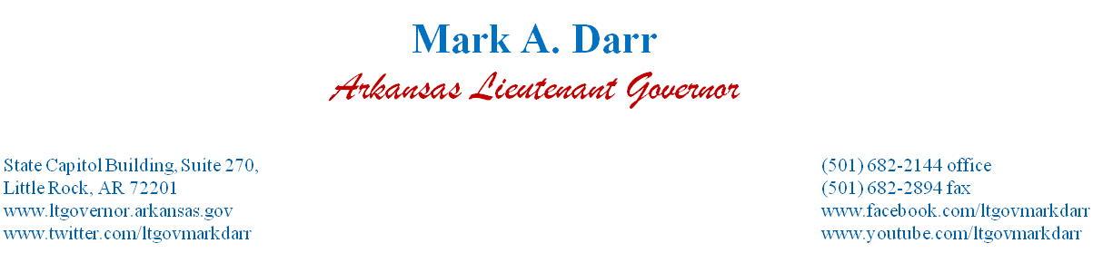

FOR IMMEDIATE RELEASE: Friday, January 10, 2014
CONTACT: Amber Pool 501-682-2198

LITTLE ROCK - It is my great honor to be the Lieutenant Governor of Arkansas. This office has allowed me to meet so many wonderful Arkansans over the past few years. My family and I are forever grateful for the support the people of this great state have shown us for the past few years and during this extremely difficult time. We have learned that difficult days demand decisions of faith.

Throughout this process, it has been my desire to share the facts, and I feel this has been accomplished. I have been honest, forthright and acted with integrity. I made mistakes, but not one with malicious intent.

Effective February 1, 2014 I will resign as Lieutenant Governor and I submit that resignation to the people of Arkansas, not an elected official. I have spoken with Speaker Carter and Senate Pro-Tempore Lamoureux to notify them of this decision. They agree with me it is in the best interest for me, my family and the state at this point. I respect these two men for their concern: not just for the state but for me and my family.

Politics can be a toxic business. I will no longer subject my family to its hard lessons. All my forgiveness to those who play the games and all my respect and appreciation to those who serve with class and humility.

Mark Darr

